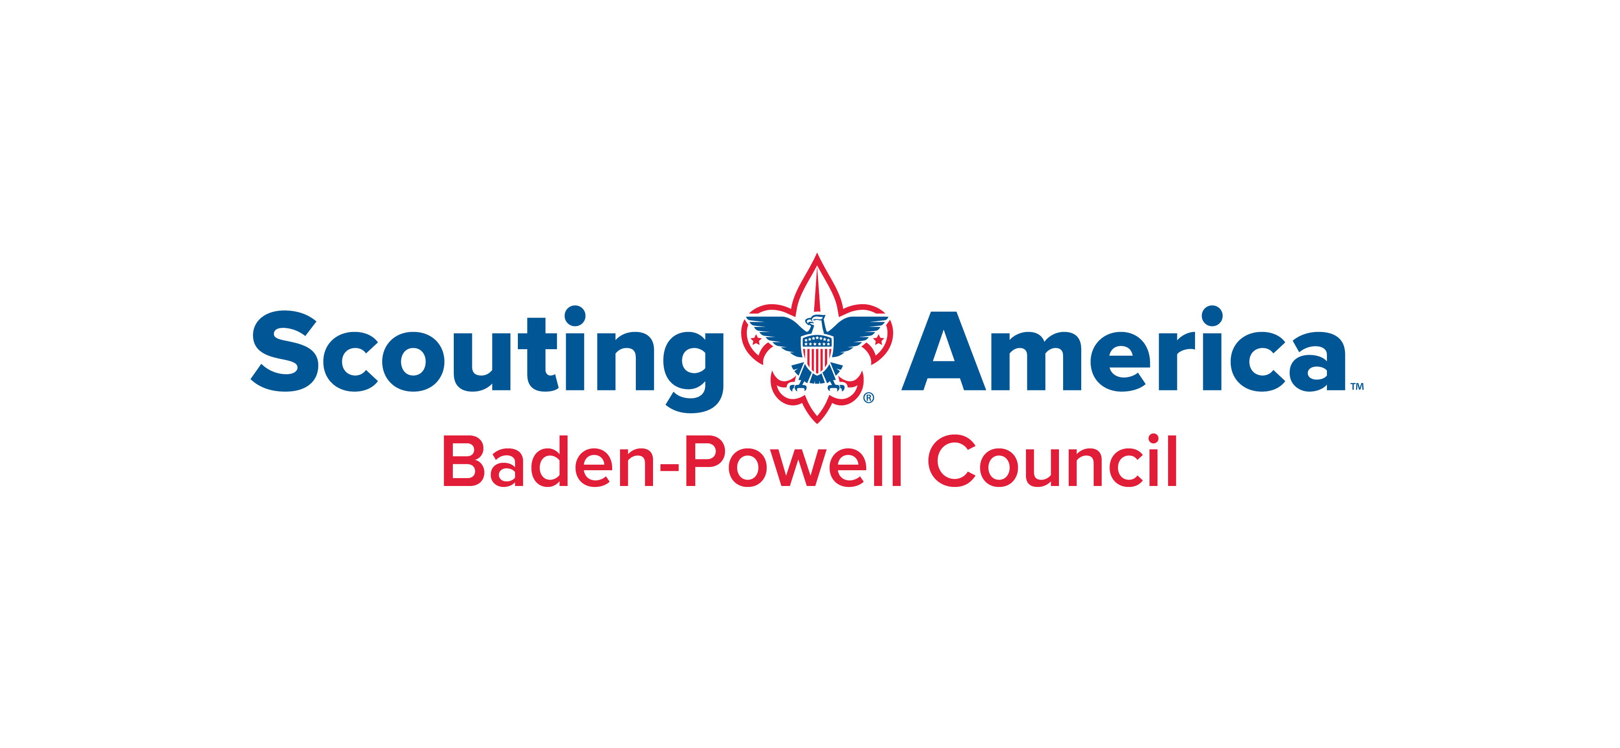

2026 Friends of Scouting Campaign

What is Friends of Scouting?
The Friends of Scouting (FOS) Campaign is our annual fund drive that engages families, businesses, and community partners to secure vital support for Scouting. Your generosity helps offset program costs and sustain the services provided by the Baden-Powell Council.

Family Campaign
Each unit is asked to host a Friends of Scouting presentation during the 2026 campaign window:
December 1, 2025 – May 30, 2026
• Presentation Length: Less than 10 minutes
• Best Settings: Courts of Honor, Blue & Gold Banquets, holiday dinners, annual banquets, or other gatherings where most parents attend
• Unit FOS Coordinator: Each unit should designate a coordinator to schedule the presentation and receive campaign updates

Presentation Information
Unit: ____________________ Community: ___________________________________ Date of Presentation: ______________________
Time: ____________ Event Type: __________________________________ Location: ___________________________________________
Unit FOS Coordinator: ___________________________________________
Phone: ___________________________________________
E-mail: ___________________________________________

Why Your Support Matters
Your contributions to the Friends of Scouting campaign make a direct impact by:
✔ Keeping camp fees affordable
✔ Providing camperships for families in need
✔ Supporting leader training and youth activities
✔ Expanding resources and services to every unit

Thank You!
With your help, Scouting remains strong and accessible for every youth in our community. Please be sure to return this to your District Executive by December 15th, 2025.

